**CSCE 312 – Lab 2 Report**

**Texas A&M University**

**February 2, 2024**

**Poyi Ou­­­**

**Problem 1:**

1. F = abc + ab + bc + ca

In my circuit design, I've used two 7408 logic gates, each taking two inputs and functioning as AND gates. Additionally, I've incorporated one 7432 logic gate, also accepting two inputs but serving as an OR gate.

1. G = a'b'+a'bc'+ab'c'

In my circuit design, I've also used one 7402 logic gate, which takes two inputs and functions as a NOR gate. Additionally, I've used one 7408 logic gate, taking two inputs, and functioning as an AND gate. Furthermore, I've incorporated one 7432 logic gate, which also accepts two inputs but serves as an OR gate.

1. The expected delay for circuit F was calculated by running through the 7408 AND gate and the 7432 OR gate, each introducing a delay of 22ns. The total expected delay is therefore 22ns * 4 gates = 88ns, where 4 is the maximum number of times the signal passed through the TTL gates.
2. The expected delay for circuit G was calculated by running through the 7402 NOR gate, the 7408 AND gate, and the 7432 OR gate, each introducing a delay of 22ns. The total expected delay is therefore 22ns * 4 gates = 88ns, where 4 is the maximum number of times the signal passed through the TTL gates.
3. For the calculation above, I used VCC = 5V, Temperature = 25°C, Resistor = 400R, Capacitance = 15pF, and all parameters were set to low-to-high level output with 22 nS max delay time.

**Problem 2:**

1. **Design Parameters**
   1. Since we are working with a total of 10 cars, we would need 10 switches in total, one for each car.
   2. Since we are working with a 7-segment display, we will need to use a total of 7 1-bit output.
   3. For the number of bits/wires required, we will use a 4-bit data bus.
   4. For the size of the encoder, since we are working with 10 cars, we will need a 16 x 4 encoder.
   5. For the size of the decoder, we will need a 4 x 7 decoder.
2. **Truth table for encoder and decoder.**

*A B C D Da Db Dc Dd De Df Dg*

0 0 0 0 1 1 1 1 1 1 0



0 0 0 1 0 1 1 0 0 0 0

0 0 1 0 1 1 0 1 1 0 1

0 0 1 1 1 1 1 1 0 0 1

0 1 0 0 0 1 1 0 0 1 1

0 1 0 1 1 0 1 1 0 1 1

0 1 1 0 1 0 1 1 1 1 1

0 1 1 1 1 1 1 0 0 0 0

1 0 0 0 1 1 1 1 1 1 1

1 0 0 1 1 1 1 1 0 1 1

. . . . . . . . . . .  
. . . . . . . . . . .  
. . . . . . . . . . .

Don’t care about the rest since we are working with 10 cars total.

**Simplified equation for the truth tables above:**

Da = A + C + BD + B’D’

Db = B’ + C’D’ + CD

Dc = B + C’ + D

Dd = B’D’ + CD’+ BC’D + B’C + A

De = B’D’ + CD’

Df =A + C’D’ + BC’ + BD’

Dg = A + BC’ + B’C + CD’

*This simplified part is used for the 4X7 decoder.

1. 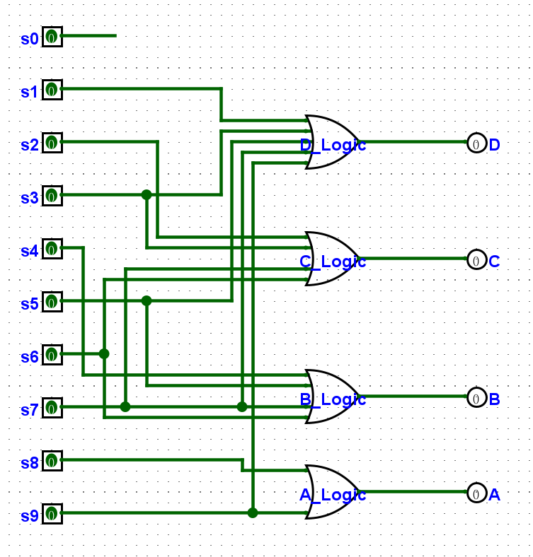A diagram of a circuit

   Description automatically generated **Logic Gates for 10X4 Encoder Using Basic Logic Gate and TTL**

In the circuit above, the logic is derived from the truth table. By utilizing 2-input TTL OR gates, we effectively converted 10 inputs into 4 outputs, thus functioning as a 10x4 encoder.

1. **Logic Gate for 4X7 Decoder using Basic Logic and TTL**

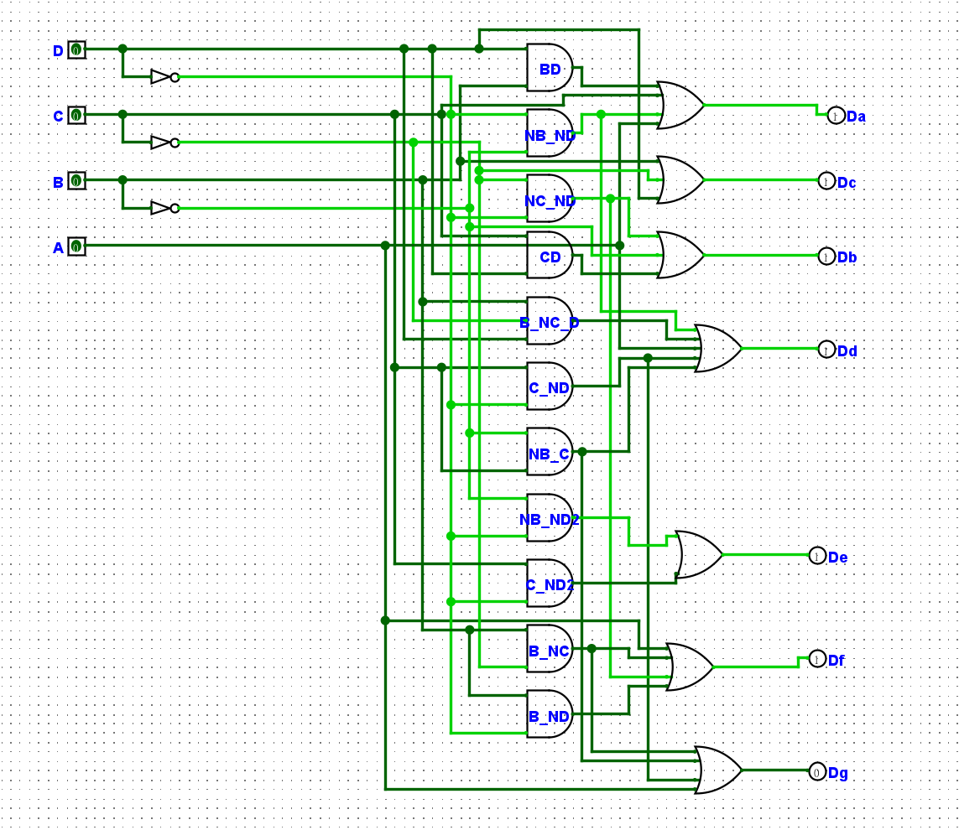

In the circuit above, the logic is derived from the simplified equation, which itself is obtained from the truth table. By utilizing 2-input TTL OR gates, 2-input TTL AND gates, and 3-input TTL AND gates, we effectively converted 4 inputs into 7 outputs, thus functioning as a 10x4 encoder.

1. **Additional Circuit: Button Pressed Circuit**

This circuit is designed to ensure that the 7-segment display only turns on if a car has pressed the button, eliminating false alarms for the security personnel.

1. **Application and Result**

After integrating the Encoder, Decoder and the Button Pressed circuit, we can effectively drive the 7-segment display by connecting the outputs to their corresponding inputs (e.g., Da to A, Db to B, etc.). In this system, the 7-segemnet display can only show if any of the buttons were pressed. And the MTA operations can signal the driver of an emergency in their car. Upon the car stopping at the next station, the driver can dispatch security personnel by reading the 7-segment display, which reflects the encoded information about the emergency.

**Example: 0**

**Example: 9**

